COMSATS University Islamabad, Lahore Campus

Department of Computer Science

SPRING 2020
□ Sessional-1 □ Sessional-II □ Terminal Examination
Course Title: | Software Project Management |  |  |  | Course Code: |  | SED320 | Credit Hours: | 3
Course Instructor/s: | Sana Rizwan |  |  |  | Programme Name: |  | BSSE
Semester: | 7th | Batch: | SP17 | Section: | A/B/C |  | Date:
Time Allowed: | 75 mins |  |  |  | Maximum Marks: |  |  | 50
Student’s Name: |  |  |  |  | Reg. No.
Important Instructions / Guidelines:
- You have 3 sections of paper, attempt all of them, there is no choice.
- Calculators are allowed.
- 1st section is Objective Part having 10 multiple choice questions; 5 True False and 5 fill in the blanks. It is of 20 marks, 20 questions and have to complete in 20 minutes.
- 2nd section is Short Question Answers; 5 questions have to complete in 20 minutes and of 15 marks.
- 3rd section is Analytical Questions; 3 questions have to complete in 35 minutes and of 15 marks.

SECTION 1 : Objective Part
Marks = 20(each question has equal marks)
Time = 20 mins
Questions = 20
- Multiple choice questions.

- What is the disadvantage of CPM/PERT?
- Critical Path Identification
- Calculate exactly how long a project will take
- Depends upon the project
- Focuses primarily on the time aspect of activities
- Assume that a change request to modify one of the deliverables has been approved by the management. Then which of the following process will help to implement the change?
- Perform integrated change control
- Direct and manage project work
- Close project or phase
- Monitor and control project work
- What is the minimum duration of an activity, called as in PERT?
- Most Likely
- Pessimistic
- Likely
- Optimistic
- What factor of a project need to be firm, for a project with deterministic time estimated so that there is a high likelihood that it will be necessary to crash the last few activities of most projects?
- Deliverables
- Cost objectives
- Budgets
- Deadlines
- What is the PERT time for each activity with optimistic, most likely and pessimistic time estimates of 6, 10, 14 days?
- 12
- 10
- 7
- 5
- What does the critical path refer to?
- Path with the largest amount of slack time
- Longest path in terms of time
- Shortest path in terms of time
- Most direct path from the beginning node to the ending node
- What characterizes a work package at the activity level, in project management?
- Can be estimated
- Completion as per plan
- No further sub-divisions
- All of these
- Which of the following options are the characteristics of effective project management?
- None of these
- Very high motivation to worker
- Less time required for development
- Lower capital cost
- Which amongst the following are the characteristics of risk management?
- Be systematic and structured
- Explicitly address uncertainly
- All of these
- Be transparent and inclusive
- Why does the activities on the critical path are termed as critical, as they?
- Cannot tolerate any delay in completion
- Represent the maximum project completion time
- Represent the most expense in terms of resources
- Represent the largest and most complex activities of the project
- Fill in the Blanks:

- The organizational structure that requires employees to report to multiple managers is referred as _______________________.
- The element of ________________, _______________ and _______________ is decreased due to different types of risks.
- The identification of risks associated with a project ________________________________________________________________________________________________________________________________________
- A project leader should perform _________________________ during forming stage.
- The ideal risk management minimizes ________________________.

- True False: ( Write your answer only T / F )
- Accept, share and avoid are the strategic option for managing risks.
- Brainstorming is a way to reach a consensus of experts.
- Standard cost is least direct cost required to complete an activity during project crashing.
- Collaborate and delegate are the initial steps to reduce project time.
- Imposed duration dates are one of the main reasons for minimizing the project duration.

SECTION 2 : Short Question Answers
Marks = 15(each question has equal marks)
Time = 20 mins
Questions = 05

- Write down any three Business Related Risk.
- Write down process activities of risk monitoring and control.
- Describe Actual cost in earned value analysis in progress metrics.
- Describe any two advantages of Cost Element Structure (CES).
- Describe versioning system and its types.

SECTION 3 : Analytical Question
Marks = 15 (each question has equal marks)
Time = 35 mins
Questions = 03

Question 1:
Instructions: Do not forget to write units. Write complete Formulas and Calculations.
Consider a software with KLOC of its main components are 32. Using COCOMO identify:
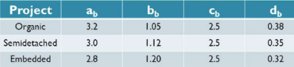
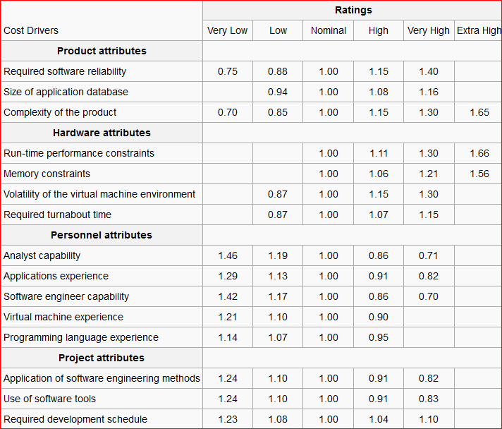
- Calculate Effort, Development Time, Average staff size and Productivity for the overall cost and schedule estimates for very low size of application database, nominal memory constraints, high required turnaround time, high application experience, very high virtual machine experience and very high use of software tools.

Effort = ________________________________________________________________________

Development Time = _____________________________________________________________

Average Staff Size = ______________________________________________________________

Productivity = ___________________________________________________________________

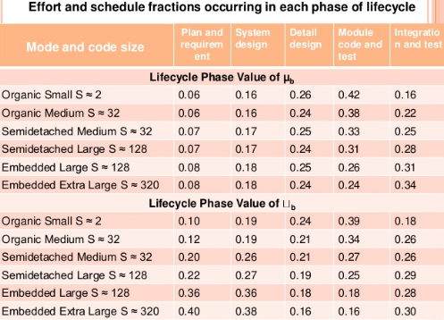
- Cost and Schedule estimates for different phases according to above given data.
Phases of Life cycle | (Effort)i | (D.T)i | (Effort)p | (D.T)p

Question 2:
Instructions: Write complete Formulas and Calculations.
Consider a project with following parameters given below:
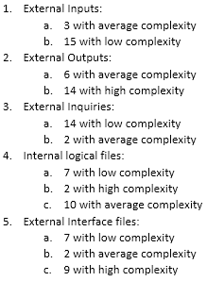
Consider 8 complexity adjustment factors are moderate, 4 are significant and 2 are essential. Compute the Final Function Point for the project.
Mention the values with formula computation:

$∑$Fi = ___________________________________________________________________________________________________

CAF = _______________________________________________________________________

UFP = _______________________________________________________________________

FFP = ________________________________________________________________________

Functional Units | Weighting Factors
 | Low | Average | High
EI | 3 | 4 | 6
EO | 4 | 5 | 7
EQ | 3 | 4 | 6
ILF | 7 | 10 | 15
EIF | 5 | 7 | 10

Question 3:
Instructions: Do not forget to write units. Write complete Formulas and Calculations.

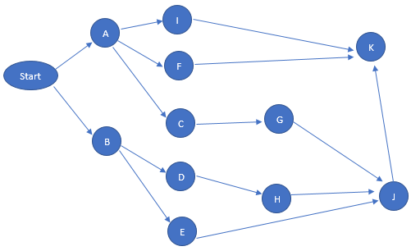
Activities | Duration | ES | EF | LS | LF
Start | 0
A | 15
B | 9
I | 12
F | 12
C | 12
D | 10
E | 29
G | 37
H | 48
K | 6
J | 6

- Identify Forward Pass for each activity
- Identify Backward Pass for each activity
- Write down critical Path according to both passes

